In order to view and apply for the tender please follow below steps;

1. Create a log in on Intend Portal - Please note that only yellow fields are mandatory for registration information on the portal.

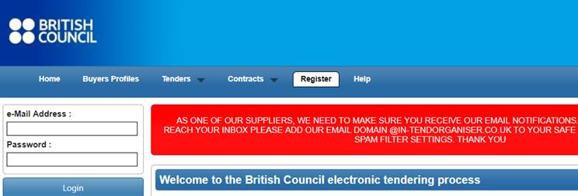

**2-** Click on **Current** under **Tenders Tab;**

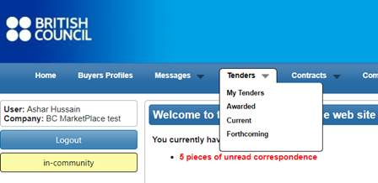

**3-** Click on the project title

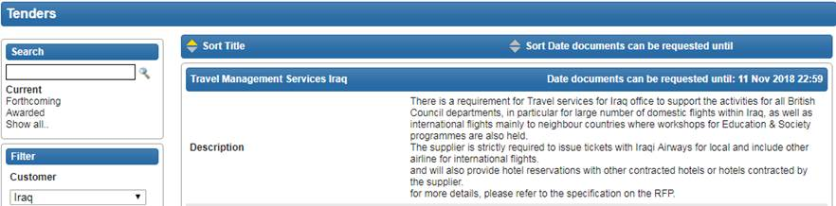

**4-** Click on **Express Interest** button at bottom



**5-** You will be able to view all the Project Details and documents under **ITT**

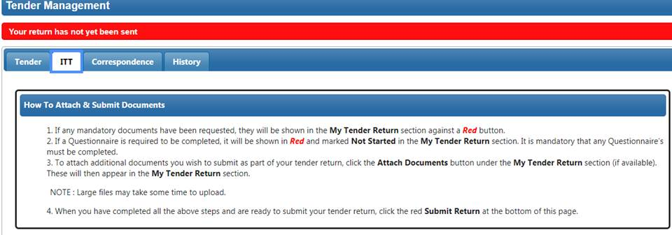

**6-** In order to submit your proposal, attach your **proposal and Bid Value** click on **Submit Return** button.

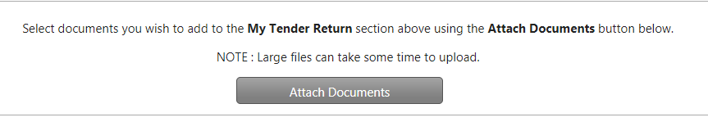

**7-** In case you want a clarification please send your correspondence to us by clicking on **Correspondence Tab**

